

MANAV RACHNA UNIVERSITY

PYTHON PT3



HIMANSHU SINHA

B-TECH CSE 4A

2K18CSUN01064

**PYTHON PT3**

**Theoretical Questions:**

1. What is the syntax to call a constructor of a base class from child class (1)

2. How is a class made as inherited class (syntax of child class) (2)

3. Print an element of a nested dictionary

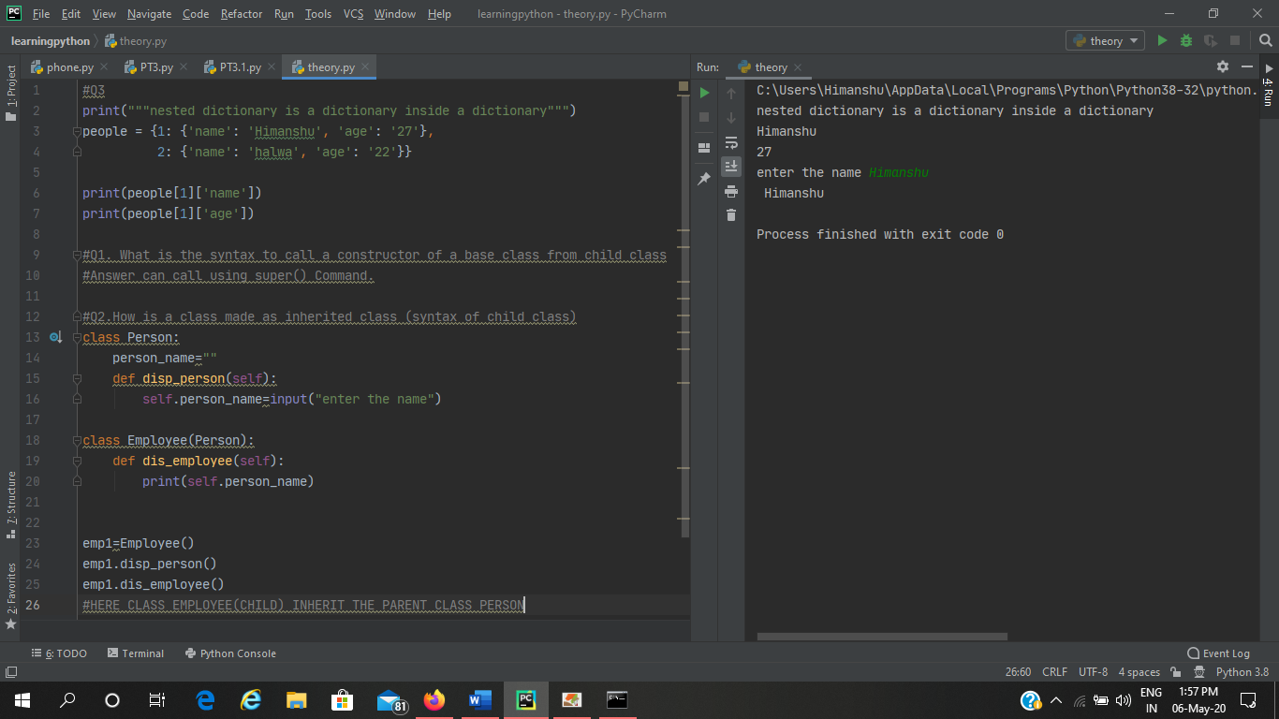

**Set C**

1. Write a program that calculates and prints the value according to the formula given

below. Take three values from user. Q= square root (( 2*value1*value2)/value3)

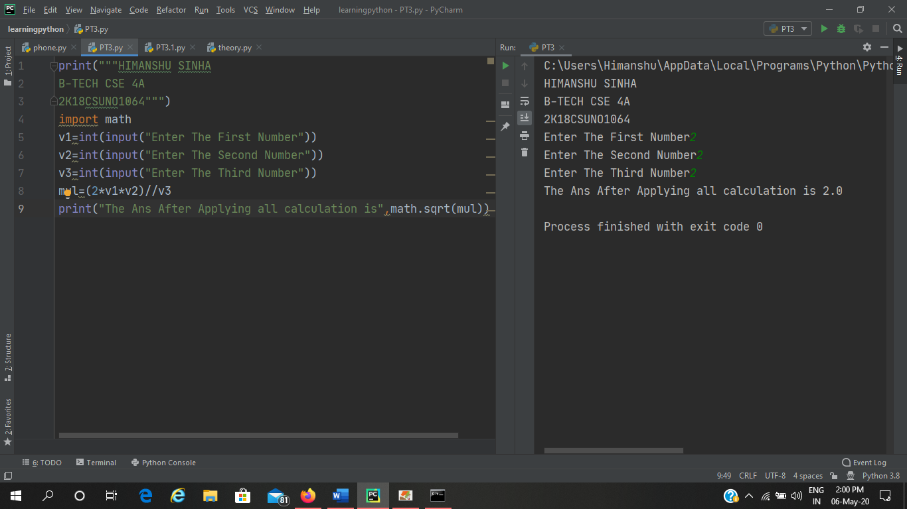

2. Please write a program which accepts a string from console and print the characters

that have even indexes.

